**QSMART – PSHG CARDS REPLACEMENT**

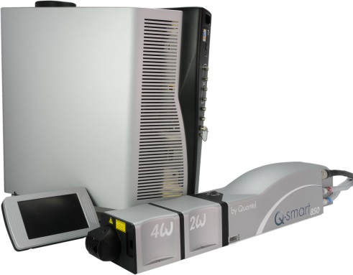**PROCEDURE**

**Toolkit:**

Allen keys

**System**: QSMART

|  |  |  |  |
| --- | --- | --- | --- |
| **4/200/1050B** | **Q-SMART 2ND HG CCA** | | |
|  |  |  |  |
| **SM010371** | **Q-SMART 3RD HG CCA** | | |
|  |  |  |  |
| **SM010372** | **Q-SMART 4TH HG CCA** | | |
|  |  |  |  |
| **SM010373** | **Q-SMART 5TH HG CCA** | | |

**Purpose**: This document details how to change a PSHG card

|  |  |  |
| --- | --- | --- |
| Revision | date | modification |
| Initial issue | July 4, 2014 |  |
|  |  |  |
|  |  |  |
|  |  |  |

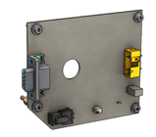

# DISASSEMBLY

* Remove the cover (2 screws M3 * 6 BHC)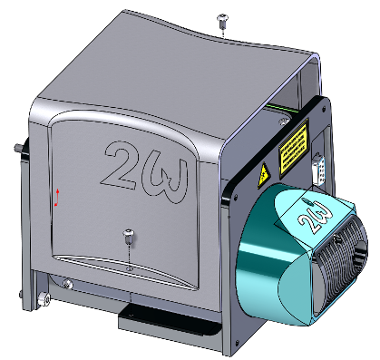

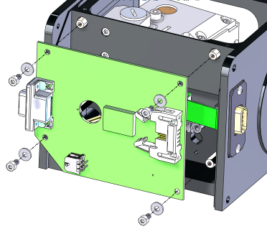

Remove the 4 screws CHC M3x6 + CS3 of the PSHG card. **Disconnect the ribbon cable (J1) and the connector (J3).**

Remove the card (**be careful with the photodiode)**

J1

J3

# INTEGRATION OF THE CARD



By paying **attention to the photodiode**, fasten the card with 4 screws CHC M3x6 + CS3 on the generator (pass the ribbon cable in front of the card). Connect the ribbon cable on J1.

The photodiode must enter here

J3

J1

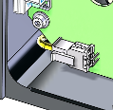

Connect J3 of the card PSHG



Attach the generator cover with two screws M3x6 BHC.